# Lab 7 Design and Layout of an Embedded System

Dhruv Sandesara and Sean Tremblay

*EKG with apple watch features*

**Deliverables (exact components of the lab report)**

A) Objectives

1-page requirements document (Combined with Part C and attached below) To baicalyy learn about the entire design phase of making an embedded system from scratch.

B) Hardware Design

Regular circuit diagram (SCH file)(attached separately)

PCB layout and three printouts (top, bottom and combined) (attached separately)

C) Software Design

Include the requirements document (Preparation a) (Combined with Part A and attached below)

D) Measurement Data

Give the estimated current (Procedure d)~80 mA

Give the estimated cost (Procedure e)~$61.45 but most free roughly ends up at $20

E) Analysis and Discussion

Include a copy of the reviewed SCH/PCB and signed by your professor (Procedure c):

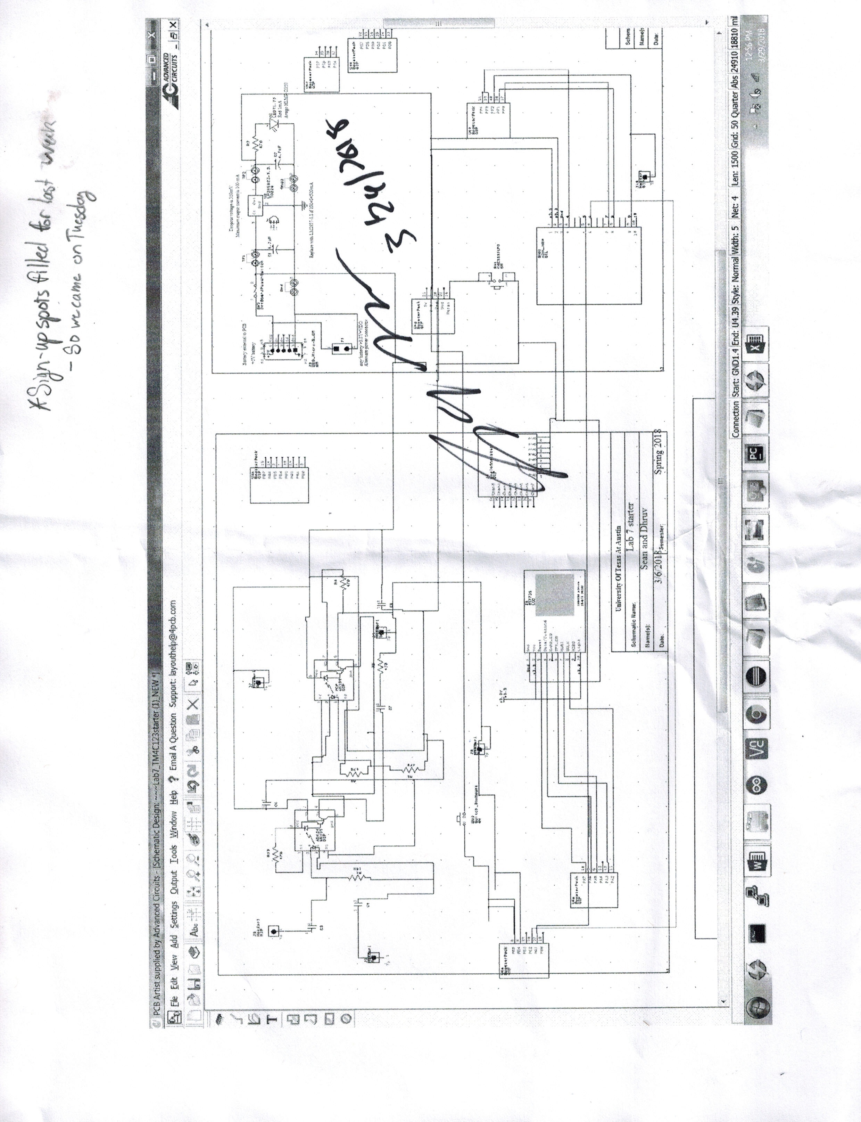

**Report (30)**

Requirements Document (10) - Due with Pre-Prep(done)

Schematic (10) - A significant amount of this grade will be on how you plan to debug your board(done)

Test points

Proper use of the logic analyzer

Professor’s signature on the SCH file (10) - Due with Lab submission along with a copy of the above(done)